Nguyễn Văn Vũ 12CNTT4
MSSV : 1250080238

SQL> CREATE USER BAITHI IDENTIFIED BY 123;
User created.
SQL> GRANT CONNECT, RESOURCE TO BAITHI;
Grant succeeded.
SQL> ALTER USER BAITHI QUOTA UNLIMITED ON USERS;
User altered.

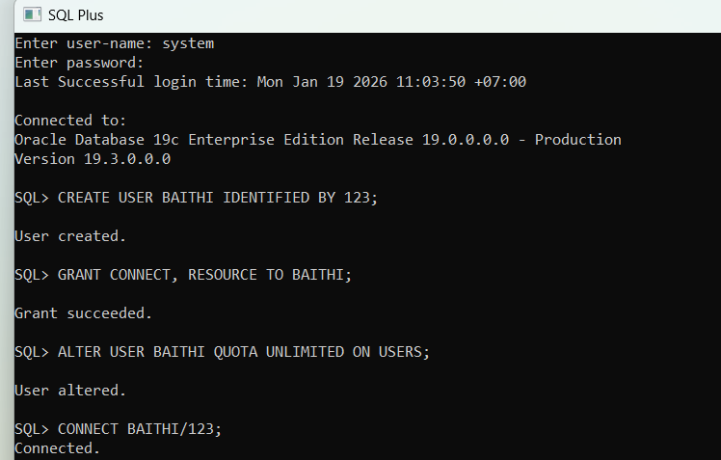

Connected.
SQL> CREATE TABLE TUYEN (
2 MATUYEN VARCHAR2(10) PRIMARY KEY,
3 BENDAU VARCHAR2(20),
4 BENCUOI VARCHAR2(20),
5 GIATUYEN NUMBER(10,0),
6 NGXB DATE,
7 TGDK NUMBER(3)
8 );
Table created.
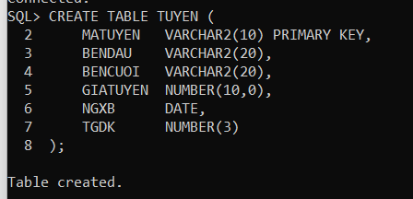

SQL> CREATE TABLE XE (
2 MAXE VARCHAR2(10) PRIMARY KEY,
3 BIENKS VARCHAR2(20),
4 MATUYEN VARCHAR2(10),
5 SOGHET1 NUMBER,
6 SOGHET2 NUMBER,
7 CONSTRAINT FK_XE_TUYEN FOREIGN KEY (MATUYEN)
8 REFERENCES TUYEN(MATUYEN)
9 );

Table created.
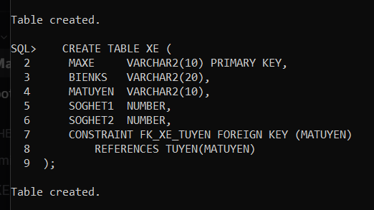

SQL> CREATE TABLE KHACH (
2 MAHK VARCHAR2(10) PRIMARY KEY,
3 HOTEN VARCHAR2(50),
4 GIOITINH VARCHAR2(5),
5 CMND VARCHAR2(20)
6 );

Table created.
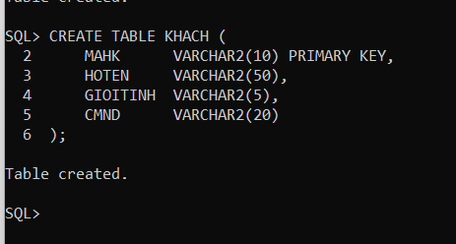

SQL> CREATE TABLE VEXE (
2 MATUYEN VARCHAR2(10),
3 MAHK VARCHAR2(10),
4 NGMUA DATE,
5 GIAVE NUMBER(10,0),
6 CONSTRAINT PK_VEXE PRIMARY KEY (MATUYEN, MAHK, NGMUA),
7 CONSTRAINT FK_VEXE_TUYEN FOREIGN KEY (MATUYEN) REFERENCES TUYEN(MATUYEN),
8 CONSTRAINT FK_VEXE_KHACH FOREIGN KEY (MAHK) REFERENCES KHACH(MAHK)
9 );

Table created.

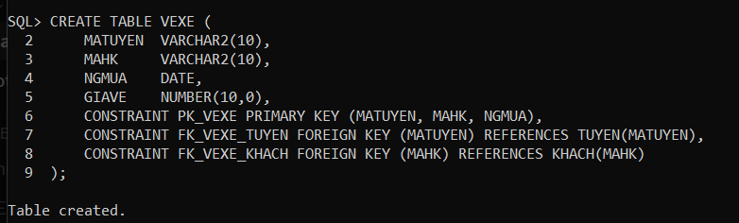
SQL> INSERT INTO TUYEN VALUES ('T11A','SG','DL',210000,TO_DATE('26/12/2016','DD/MM/YYYY'),6);
1 row created.
SQL> INSERT INTO TUYEN VALUES ('T32D','PT','SG',120000,TO_DATE('30/12/2016','DD/MM/YYYY'),4);
1 row created.

SQL> INSERT INTO TUYEN VALUES ('T06F','NT','DNG',225000,TO_DATE('02/01/2017','DD/MM/YYYY'),7);

1 row created.

SQL> INSERT INTO XE VALUES ('X01','52LD-4393','T11A',20,20);

1 row created.
SQL> INSERT INTO XE VALUES ('X02','59LD-7247','T32D',36,36);
1 row created.
SQL> INSERT INTO XE VALUES ('X03','55LD-6850','T06F',15,15)
1 row created.
SQL> INSERT INTO KHACH VALUES ('KH01','Lâm Văn Bền','Nam','655615896');
1 row created.
SQL> INSERT INTO KHACH VALUES ('KH02','Dương Thị Lục','Nữ','275648642');
1 row created.
SQL> INSERT INTO KHACH VALUES ('KH03','Hoàng Thanh Tùng','Nam','456889143');
1 row created.
SQL> INSERT INTO VEXE VALUES ('T11A','KH01',TO_DATE('20/12/2016','DD/MM/YYYY'),210000);
1 row created.
SQL> INSERT INTO VEXE VALUES ('T32D','KH02',TO_DATE('25/12/2016','DD/MM/YYYY'),144000);
1 row created.
SQL> INSERT INTO VEXE VALUES ('T06F','KH03',TO_DATE('30/12/2016','DD/MM/YYYY'),270000);
1 row created. 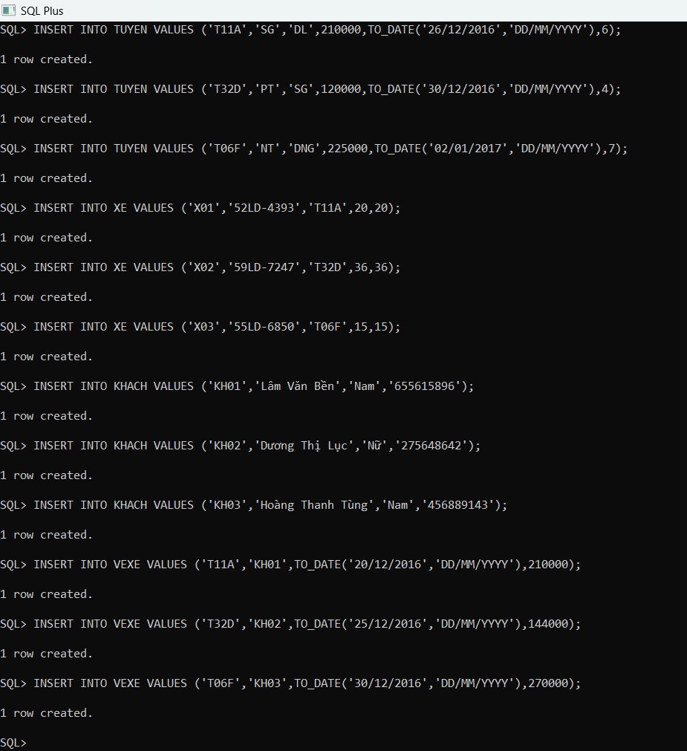
SQL> ALTER TABLE TUYEN ADD CONSTRAINT CK_TUYEN_GIA
2 CHECK ( (TGDK <= 5) OR (GIATUYEN > 200000) );

Table altered.

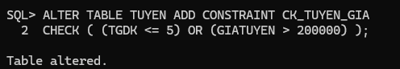
SQL> CREATE OR REPLACE TRIGGER TRG_TANG_GIA
2 BEFORE INSERT OR UPDATE ON TUYEN
3 FOR EACH ROW
4 BEGIN
5 IF :NEW.NGXB BETWEEN TO_DATE('29/12/2016','DD/MM/YYYY')
6 AND TO_DATE('05/01/2017','DD/MM/YYYY') THEN
7 :NEW.GIATUYEN := :NEW.GIATUYEN * 1.2;
8 END IF;
9 END;
10 /

Trigger created.

SQL> SELECT *
2 FROM VEXE
3 WHERE EXTRACT(MONTH FROM NGMUA) = 12
4 ORDER BY GIAVE DESC;

MATUYEN MAHK NGMUA GIAVE
---------- ---------- --------- ----------
T06F KH03 30-DEC-16 270000
T11A KH01 20-DEC-16 210000
T32D KH02 25-DEC-16 144000

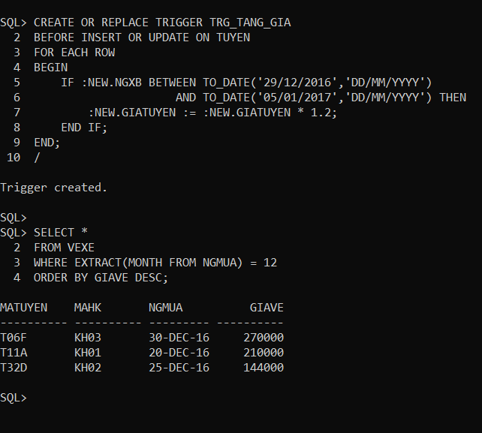

SQL> SELECT MATUYEN
2 FROM VEXE
3 WHERE EXTRACT(YEAR FROM NGMUA) = 2016
4 GROUP BY MATUYEN
5 HAVING COUNT(*) = (
6 SELECT MIN(COUNT(*))
7 FROM VEXE
8 WHERE EXTRACT(YEAR FROM NGMUA) = 2016
9 GROUP BY MATUYEN
10 );

MATUYEN
----------
T06F
T11A
T32D

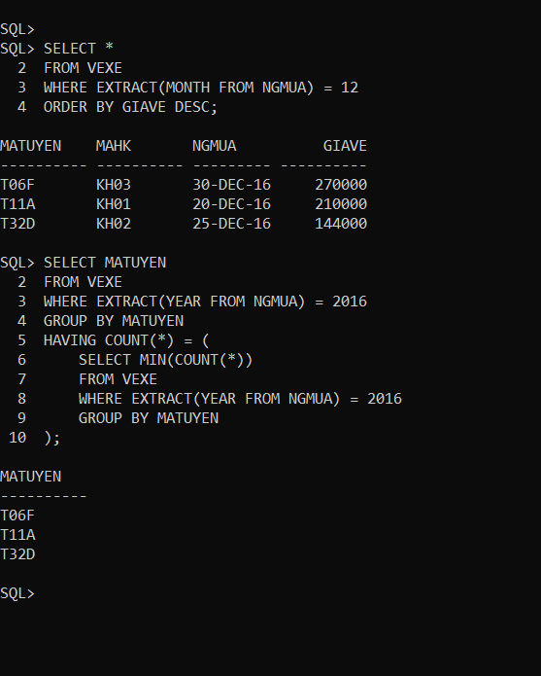

SQL> SELECT V.MATUYEN
2 FROM VEXE V
3 JOIN KHACH K ON V.MAHK = K.MAHK
4 GROUP BY V.MATUYEN
5 HAVING COUNT(DISTINCT K.GIOITINH) = 2;
no rows selected
SQL> SELECT K.MAHK, K.HOTEN
2 FROM KHACH K
3 WHERE K.GIOITINH = 'Nữ'
4 AND NOT EXISTS (
5 SELECT T.MATUYEN
6 FROM TUYEN T
7 MINUS
8 SELECT V.MATUYEN
9 FROM VEXE V
10 WHERE V.MAHK = K.MAHK
11 );
no rows selected

